Conservation Education
Pre & Post Content-Water Conservation
www.iercd.org

LESSON: Cloud Jars
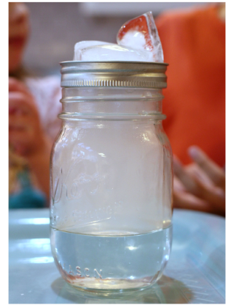
Grade level: 4th through 5th grade
NGSS: 4-ESSS2-1. Make observations and/or measurements to provide evidence of the effects of weathering or the rate of erosion by water, ice, wind, or vegetation.
NGSS: 5-ESS2-1. Develop a model using an example to describe ways the geosphere, biosphere, hydrosphere, and/or atmosphere interact.

Introduction
Comprehension of the critical role played by water in support of all life on Earth is an essential foundational element of the Inland Empire Resource Conservation District’s (IERCD’s) Water Conservation classroom presentation. This activity is being provided to encourage students to examine closer the simple concept of condensation and to increase student preparation for IERCD program participation. The suite of concepts and vocabulary covered will depend on length of activity facilitated by the participating teacher, but at any length should increase student preparation for IERCD program participation. It would also be suitable for post-program facilitation, to reinforce concepts and vocabulary covered during the program for maximum content retention.

Objective
By completing the activities, the students will:
- Be refreshed on the water cycle
- Illustrate the water cycle with specific focus on condensation
- Be introduced to general concepts and vocabulary that will be covered during IERCD’s Water Use Efficiency classroom presentation.

Summary:
This activity demonstrates how clouds are formed during the water cycle and will work in preparation or reinforcement of the IERCD Water Use Efficiency program.

Background:
The water we have now is the water we had at the beginning of time. Water forms, dissipates, and forms again in a cycle called the hydrologic or water cycle.
The water cycle is a gigantic circulation system operating in the atmosphere and on the Earth’s lands and oceans. Being a cycle, there is no beginning or ending. Water is transferred from the land to the atmosphere from the soil and other surfaces through evaporation, while water is given off by plants through transpiration. This combined process is referred to as evapotranspiration.
The water enters into the atmosphere and in turn cools and condenses into clouds, and then falls back to the Earth’s surface as precipitation. Precipitation that falls as rain, hail, dew, snow, or sleet is important to all living things. After wetting the foliage and the ground, some of the precipitation runs off into streams and other waterways. This is the water that often causes erosion and is the main contributor to floods.
Not all of the precipitation runs off, as some of it pools and becomes available for evaporation. Some of it slowly infiltrates (soaks in) into the ground.

Materials:
- 3 to 4 Glass jars (depending on the size of the class)
- Several ice cubes
- 3-4 jar lids
- Hot water

Skills developed:
- Analyzing
- Interpreting

Directions:
- Gather a glass jar, ice cubes, and a jar lid. Talk about clouds and fog, and deduce together with the children that both substances are made from the same type of vapor.
- While the class watches, pour the hot water into the jar. Fill the jar a quarter of the way from the top. Assign a volunteer to place the plate on top of the jar, and then assign another volunteer to place ice cubes on top of the plate. Fog will form inside the jar and water droplets will gather on the glass.
- This process may take a few minutes, so sing a short transitional song or read a short story while waiting for the formation. The children may be too young to fully understand the process of mixing hot air pressure with colder currents, but they will understand they made a cloud in their classroom.

Extension:
- Have students write down what they observed and discuss as a class. You could also have the class research when warm air meets a mass of cold air.
A warm front occurs when a mass of warm air meets a mass of cold air. The warm air slowly rises above the cold air, forming a low pressure zone. As the rising warm air cools, the moisture in it condenses to form clouds, bringing drizzle or rain.

- Do the experiment and during the waiting period have students write down the procedures and list materials used. Prior to the start of the experiment have students come up with hypothesis of the outcome of the experiment in order to explore the scientific method.

