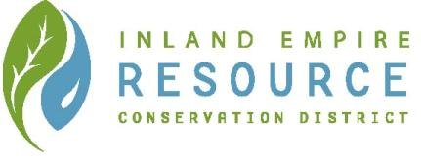
Conservation Education
Pre & Post Content – Water Conservation
www.iercd.org

LESSON: Groundwater Demonstration
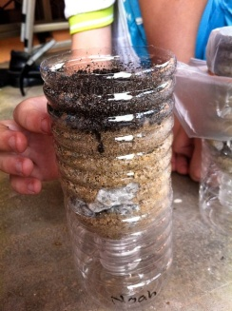
Grade level: 6th through 8th grade
NGSS: MS-ESS2-4. Develop a model to describe the cycling of water through Earth’s system driven by energy from the sun and the force of gravity.
MS-ESS3-1. Construct a scientific explanation based on evidence for how the uneven distribution of Earth’s mineral, energy, and groundwater resources are a result of past and current geosciences processes.

Introduction:
Comprehension of the critical role played by water in support of all life of earth is an essential foundational element of the Inland Empire Resource Conservation District’s Water Conservation classroom presentation. This activity is being provided to increase student awareness of water uses and benefits prior to program facilitation, and encourages development of this knowledge in a free-form, group exercise. The suite of concepts and vocabulary covered will depend on length of activity facilitated by the participating teacher, but at any length should increase student preparation for IERCD program participation. It would also be suitable for post-program facilitation, to reinforce concepts and vocabulary covered during the program for maximum content retention.

Objective:
By completing the activities, the students will:
- Learn how water flows into the ground through a demonstration.
- Learn how groundwater gets filtered through different types of soil.

Background:
An aquifer takes a long time to form; some aquifers are millions of years old. An aquifer is an underground layer of water-bearing permeable rock, rock fractures or unconsolidated materials, from which groundwater can be extracted using a well. Water slowly infiltrates into permeable surfaces over time, eventually this water will reach the water table. In reality it could take many years for water to reach the water table which is why water conservation is so important. People are drawing up water faster than they are recharging the aquifers. Groundwater supplies are replenished, or recharged, by rain and snow melt that seeps down into the cracks and crevices beneath the land's surface.

Summary:
This activity demonstrates how water infiltrates into the ground and how infiltration is impacted by different types of soil.

Materials:
- Sets of 3 clear plastic cups approximately 16 – 20 ounces. 1 set pre group.
- Gravel
- Sand
- Clay
- Soil
- Magnifying glass (optional)
- Sets of 3 separate cups of water 8 ounces each. 1 set pre group.
- Sets of 3 cups for drainage, 1 set pre group.

Skills developed:
- Listening
- Analyzing
- Critical Thinking

Directions:
- Have students document each step.
- Split students in groups of 4 or 5. Have each group place gravel, sand and clay in separate clear cups. Have students look closely at each cup.
- To demonstrate how ground water moves through underground rock formations, have the groups pour water into each cup; observe and discuss the result with the students.
- Have students hypothesis the outcome for each cup?
- Ask the students: Which material allowed the water to soak down the fastest? The slowest? How would the different materials influence water movement in natural systems?
- Now have the students poke a hole at the bottom of each cup, drain and capture the water.
- Next add soil on top of the gravel, sand and clay; pour dirty water over the soil to demonstrate the filtration that occurs in the ground. Capture the water in clear cups to be examined by the group.
- Research how much of the water provided in their area comes from groundwater.

Extension:
- Discuss with the class the possible contaminants that can make their way to groundwater and then have student’s research threats to groundwater in their region. For more content visit
http://www.groundwater.org/get-informed/groundwater/contamination.html

- Edible Aquifer Parfaits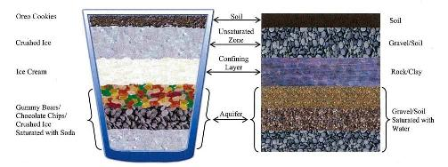
Objective: To teach about the geologic formations in an aquifer.
Focus: Groundwater and aquifers. Students will build their own edible aquifer and learn about geologic layers, confining layers, contamination, recharge and water tables. The students will have a better understanding about the need to protect and conserve groundwater resources.
Materials needed (for a class of 25)
- Chocolate chips (4, 12 oz bags)
- Oreo cookies (2 packages)
- Crushed ice (the smaller the better)
- Vanilla ice cream (one 5-quart bucket yields 60 aquifers at one generous scoop per student)
- Clear soda pop (Sprite, lemon-lime) (4 liters)
- Colored soda Ex: strawberry, grape (1 liter)
- Small gummy bears or gummy worms (small) (2 lbs)
- Drinking straws (clear work best) (25-30)
- Clear plastic cups (12 or 16 oz) (25-30)
- Spoons (25-30)
- Ice cream scoop
Activity Steps
1. Review "What is groundwater?" and vocabulary terms in the groundwater glossary.
2. Begin to construct your edible aquifer by filling a clear plastic cup 1/3 full with gummy bears, chocolate chips, or crushed ice. These represent gravel & soil that make up the aquifer.

3. Add enough soda to just cover the candy or ice. The soda represents groundwater. Notice that the soda fills all of the spaces among the gummy bears, chocolate chips and ice. The aquifer is now saturated with soda; it is a "saturated zone." In an unconfined aquifer, the top of the saturated zone is called the "water table."
4. Add a layer of ice cream to serve as a "confining layer" over the water-filled aquifer. Discuss what a confining layer is and does. This layer, called a "confining layer" or an "aquitard" is impermeable or significantly less permeable than the aquifer below it (it is difficult for water to soak through). It helps protect the aquifer from contamination and is usually made of rock and/or clay. An aquifer under a confining layer is called a "confined aquifer." An aquifer without a confining layer is called an "unconfined aquifer."
5. Add crushed ice on top of the confining layer/water table. This represents the unsaturated zone, the area where air fills most of the pores (spaces) in the soil and rock.
6. Scatter Oreo cookies over the top. This represents the soil, which is very porous (top soil).
The aquifer is now complete. Your aquifers will probably be messy and not look like the picture on the front page. That's OK! Real aquifers aren't neatly layered either.
7. Sprinkle colored soda over the top. The soda represents contamination. Does anything happen to the soda right away? (Usually nothing will happen.)
8. Using a drinking straw, drill a well into the center of your aquifer. Observe the aquifer and soda. What, if anything, happens when the well is drilled?
9. Slowly begin to "pump" the well by sucking on the straw. Watch the decline in the level of the clear soda and observe what happens to the contaminants. Do contaminants leak through the confining area (ice cream) and get sucked into the well? If so, do more contaminants get into wells in confined or unconfined aquifers?
10. Pour a small amount of clear soda over the top. The soda represents precipitation. It recharges the aquifer (adds new water). Watch how the colored soda moves into the aquifer. The same thing happens when contaminants are spilled on the ground. Do you think you could get the colored soda back out of the clear soda?
11. Review what you have learned as you enjoy eating your edible aquifer.
Warning Check with your students before conducting this activity to see if anyone is diabetic or lactose intolerant. Make substitutions if needed.

